4-H Online 2.0 Animal Entry Guide
Sheep Projects (Breeding and Market)
*Note: For 4-H Members 8 and above

Log into 4-H Online

- Use your family email and password co.4honline.com

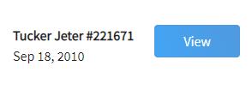
Click “View”, next to Member’s Name

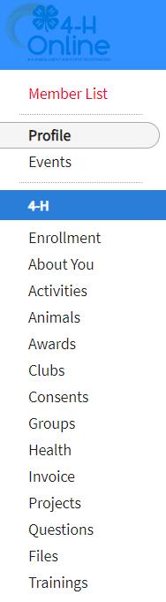
Locating ‘Animals’
- Desktop, select “Animals” from the left side navigation

- Smart Phone or Tablet, click on the 3 bars in the top left corner
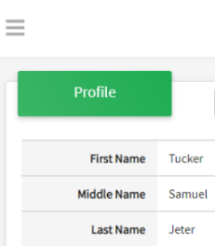
With either option, this will bring up a drop down list to begin adding Animals.

Adding an Animal
- Click "Add an Animal"
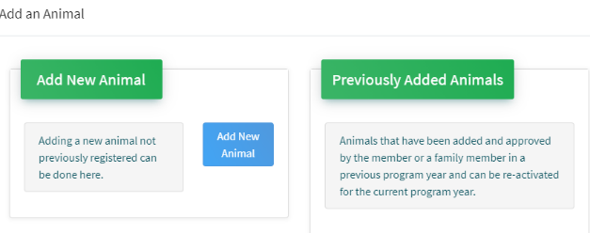Then select “Add New Animal”
- Select the specific sheep type, from the drop down. REQUIRED: Enter Animal Tag or “000”, if unknown, click “Save”
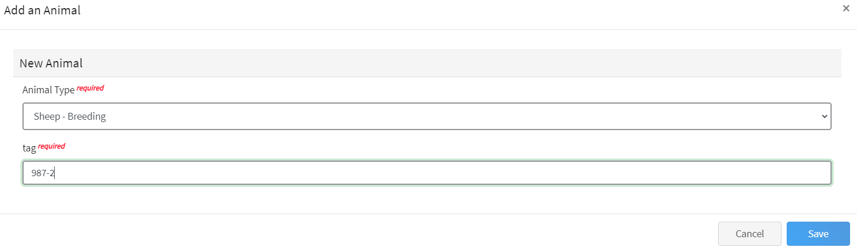
- Next, click “Show Questions”
Animal Entry is open for the current enrollment year. - Is all information complete? Check all county animal entry deadlines.
READ All County instructions for each animal species as county requirements vary.
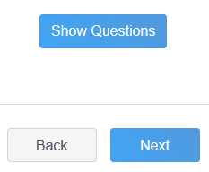
- Enter the animal’s name. This would be the unique name to identify the animal.
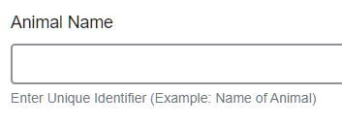

- Enter the date of animal’s birth or purchase date and weight, if applicable.
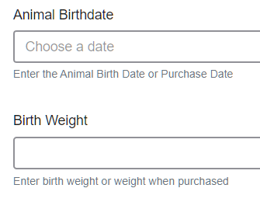

- Enter the Breed information. If Breed is not listed select “Mixed Breed” or “Other Breed” – Only select 1 Breed.
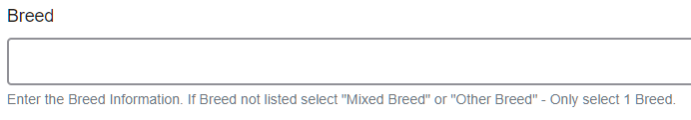
- Enter the distinguishing colors or markings.
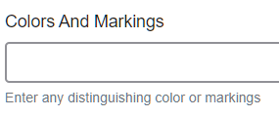
- Enter Dam Tag and Tattoo, if applicable in your county. This is only on the breeding entry, not market.
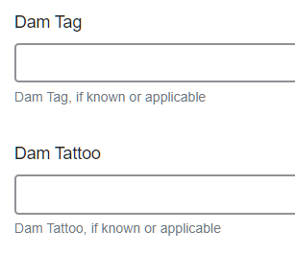
- Enter Premises or Location ID, if applicable in your county. This is only on the breeding entry, not market.
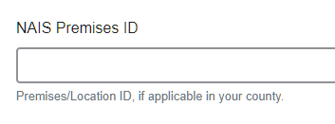
- Enter the Scrapie Flock ID, if applicable.
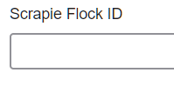
- The Tag number be brought over from the first screen, as this is required. This field can be updated to reflect the correct tag of the animal. Enter a Tattoo number or 0, if not applicable.
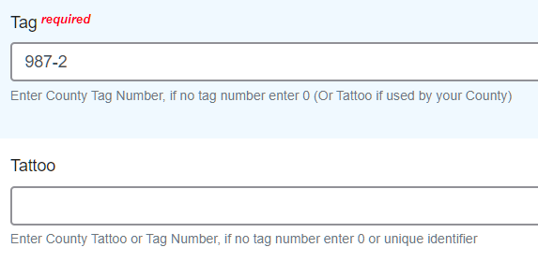
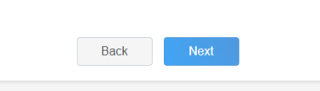
- Click “Next”, continue with the “File Uploads” that are required by your local county extension office. These will vary by county and species. Please follow all your county guidelines.
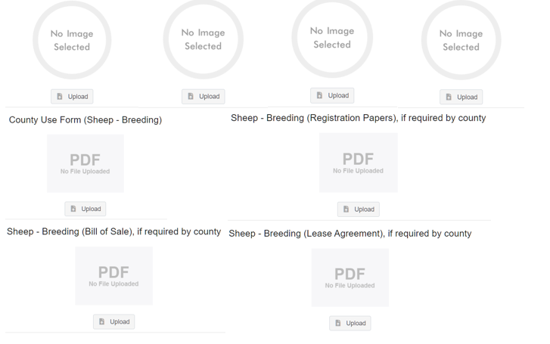

- Confirm all information, click ‘submit’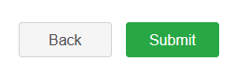
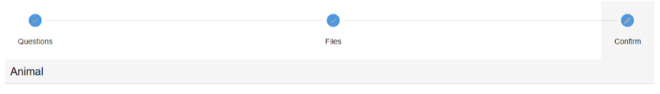
- County Extention staff, will review all information. If more is needed, members can edit. Once “Approved” by your local county extension office an email will be sent to your family account (example below) A time and date stamp for each animal.
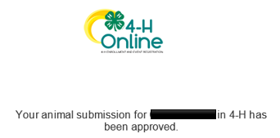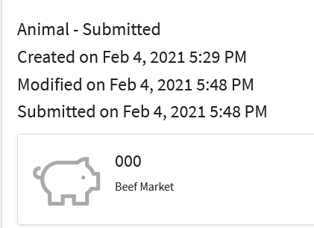
Questions, please contact your local extension staff.

